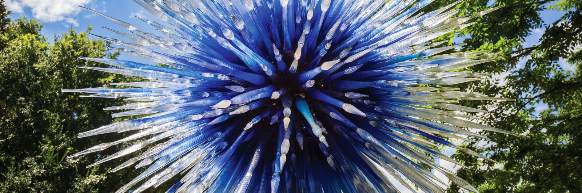

BUS TOUR
September 15, 2017

CHIHULY - EXPLORE ART & GLASS IN NATURE
Enjoy a day at the New York Botanical Gardens
Self-guided tour of the gardens & art work either walking or riding a tram
Lunch on your own
Dinner included at Frank Guido’s Little Italy in Kingston
A family style meal including salad, 2 entrees, dessert & coffee, tea or soda

Buses leave from Queensbury & Wilton
Sponsored by the Federated Garden Clubs of NYS, Inc.
Members $94 – non-Members $99

Contact: bmillington@msn.com or 518-587-3085

